**Project Design Phase-II**

**Data Flow Diagram & User Stories**

|  |  |
| --- | --- |
| Date | 26 October 2023 |
| Team ID | PNT2022TMIDxxxxxx |
| Project Name | Fake/Real Logo detection using deep learning |
| Maximum Marks | 4 Marks |

**Data Flow Diagrams:**

A Data Flow Diagram (DFD) is a traditional visual representation of the information flows within a system. A neat and clear DFD can depict the right amount of the system requirement graphically. It shows how data enters and leaves the system, what changes the information, and where data is stored.

**Diagram:**

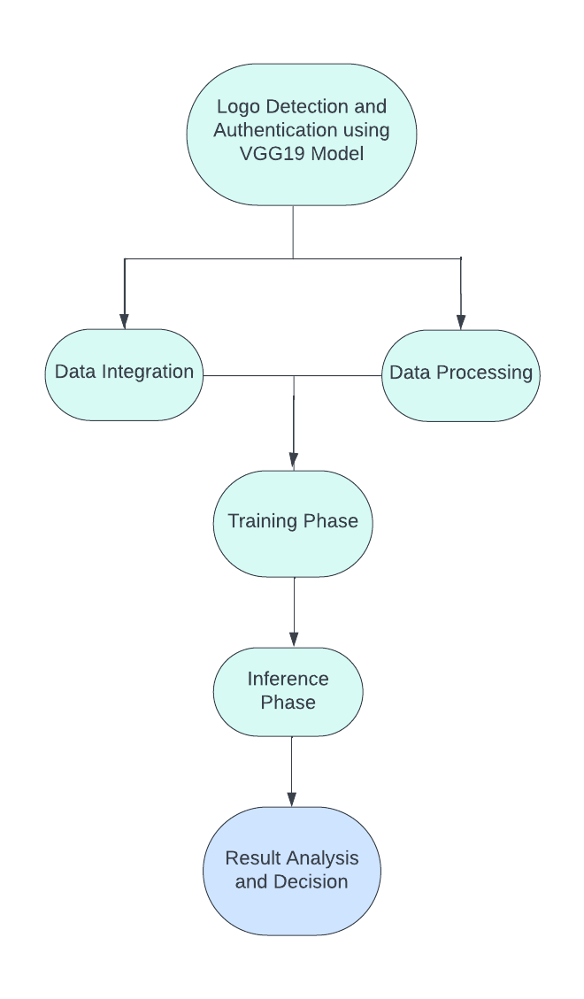

Explanation:

1. Data Ingestion and Preprocessing:

• This step involves gathering and preparing the logo images for training or inference.

• Data can come from various sources such as databases, web scraping, or user uploads.

• Preprocessing includes resizing, normalizing, and augmenting the images to make them suitable for the CNN model.

2. Training Phase :

• In this optional step, you train the VGG19 CNN model using labeled data to teach it to differentiate between real and fake logos.

• The trained model learns to extract relevant features from logo images.

3. Inference Phase:

• New logo images are fed into the trained VGG19 model.

• The model processes the images through its layers and generates predictions (confidence scores or probabilities) for each logo's authenticity.

4. Result Analysis and Decision:

• The predictions from the inference phase are analyzed to determine whether a logo is real or fake.

• A predetermined threshold value can be applied to convert the confidence scores into a binary decision (real or fake).

• The result may trigger further actions, such as flagging potential counterfeits, notifying brand owners, or updating a database with authentication results.

**User Stories**

|  |  |  |  |  |  |  |
| --- | --- | --- | --- | --- | --- | --- |
| User Type | Functional Requirement (Epic) | User Story/Task | User Story Number | Acceptance Criteria | Priority | Release |
| Brand owner | Protect brand identity and prevent fraud | Automatically detect fake logos | US-1 | The system can detect fake logos with an accuracy of at least 95%. | High | Sprint 1 |
| Brand owner | Automate logo authentication | Get notified of unauthorized logo usage | US-2 | The system can generate alerts for unauthorized logo usage. | Medium | Sprint 2 |
| Consumer | Ensure the authenticity of products or services | Verify the authenticity of logos before making a purchase | US-3 | The system can provide consumers with a way to verify the authenticity of logos. | Low | Sprint 3 |
| Brand owner | Train the system to detect specific brand logos | Train the system to detect my specific brand logo | US-4 | The system can be trained to detect specific brand logos with an accuracy of at least 95%. | High | Sprint 4 |
| Brand owner | Customize the system to alert for specific types of unauthorized logo usage | Customize the system to alert me of specific types of unauthorized logo usage | US-5 | The system can be customized to alert brand owners of specific types of unauthorized logo usage. | Medium | Sprint 5 |
| Consumer | Easily access the system to verify the authenticity of logos | Easily access the system to verify the authenticity of logos | US-6 | The system can be accessed by consumers through a mobile app or website to verify the authenticity of logos. | Low | Sprint 6 |